Resize the document to fit your screen using the zoom function on the menu above.
Oak lessons |  |  |  |  |  |  |  |  |  |  |  |  |  |  |  |  |  |  |  |  |  |  |  |  |  |  |  |  |  | 
In the 2022 school year, an average of 102,000 pupils and 30,000 teachers were using the Oak website each week. Teachers downloaded a total of 1.13m resources and 9.6m lessons were taken by pupils. These numbers demonstrate the reach Oak has, with projected further growth each academic year. Further to this, Oak is also used as a professional development tool to support and develop knowledge of subject content, especially for non-specialists and for those supporting Early Career Teachers.

With this level of impact, it is essential that lessons at Oak are planned and delivered by expert teachers like yourself. The breakdown below gives examples of how a single lesson may be used:

32% Setting cover

30% Setting remote learning

47% Lesson planning

43% Curriculum planning

31% Using slides in lessons

38% Setting homework

27% Professional development

*a teacher may use the lesson in multiple ways hence not adding up to 100%

With a wide range of ‘use-cases’, and no single way being dominant, Oak supports this by taking the lessons you create and converting them into two digital products:

- Downloadable teaching resources: for teachers to deliver the lesson in a classroom.
- Online lessons: focused on pupils being able to study the lesson remotely.

Before getting stuck into the details, we need to look at the headline features of lessons at Oak. The following is covered in this guide:

 |  |  |  |  |  |  |  |  |  |  |  | 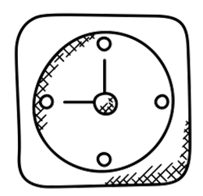 |  |  |  |  |  |  |  |  |  |  |  |  |  |  |  |  |  |  |  |  |  |  |  | 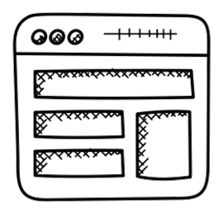 |  |  |  |  |  |  |  |  |  |  |  | 
Lesson components |  |  |  |  |  |  |  |  |  |  |  | Lesson duration |  |  |  |  |  |  |  |  |  |  |  | Creation process |  |  |  |  |  |  |  |  |  |  |  | Lesson structure |  |  |  |  |  |  |  |  |  |  |  | Lesson vocabulary

Lesson components

There are eight components to a single Oak lesson.

- Lessons within a unit form a coherent whole and are sequenced thoughtfully so that content builds cumulatively.

- Lessons will be suitable for in school delivery and remote learning.

- Lessons can be adapted by the end user.

- Lesson resources complement each other but can also be used independently of each other.

- The slide deck is suitable for in-class use and for use in the video.

- The slide deck provides the necessary visual content to support teaching.
 |  |  |  |  |  |  |  |  |  |  |  |  |  |  |  |  |  |  |  |  |  |  |  |  |  |  |  |  |  |  |  |  |  |  |  |  |  |  |  |  |  |  |  |  | 
Curriculum information |  |  |  |  |  |  |  |  |  |  |  |  |  |  | Slide deck |  |  |  |  |  |  |  |  |  |  |  |  |  |  | Worksheet and answers |  |  |  |  |  |  |  |  |  |  |  |  |  |  | Video
 |  |  |  |  |  |  |  |  |  |  |  |  |  |  |  |  |  |  |  |  |  |  |  |  |  |  |  |  |  |  |  |  |  |  |  |  |  |  |  |  |  |  |  |  | 
Prior knowledge starter quiz |  |  |  |  |  |  |  |  |  |  |  |  |  |  | Exit assessment quiz |  |  |  |  |  |  |  |  |  |  |  |  |  |  | Additional materials |  |  |  |  |  |  |  |  |  |  |  |  |  |  | Transcript
NB The transcript will be automatically generated and not all subjects and lessons will have additional materials.

Lesson duration

When taught in a classroom, Oak lessons are designed to take:

50-60 minutes for KS2-4   |  |  |  |  |  |  |  |  |  |  |  |  |  |  |  |  |  |  |  |  |  |  |  |  |  |  |  |  |  | 40 minutes for KS1  
These time allocations include the time taken to complete the prior knowledge starter quiz and the assessment exit quiz.

Lesson creation process

To support you in planning lessons, the diagram below suggests how and when to approach the creation of each component. This is for pedagogical purposes but also supports the review process. You may find, due to the nature of your subject, there may be some differences to your approach.

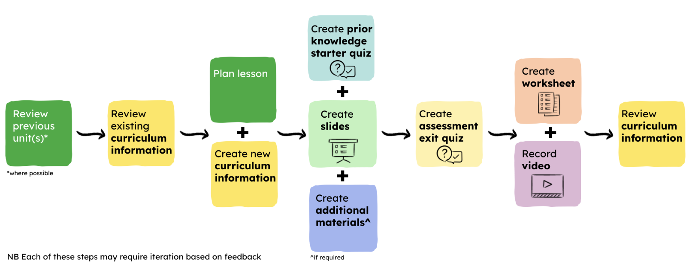
Curriculum information is an umbrella term describing all the information that creates a full curriculum. This includes information such as unit and lesson titles, key learning points (the main knowledge which needs to be covered within a lesson), keywords and lesson outcomes. You need to review this information prior to starting to plan lessons. You will find there is some curriculum information that will need to be developed during the lesson creation process e.g. teacher tips. It is also important to return to curriculum information throughout the process to ensure the lesson adheres to the curriculum for which it is being created.

From our experience creating lessons, coherence can be a challenging aspect. Creating slide decks alongside additional materials and the prior knowledge starter quiz has helped to bind these components together.

The worksheet and video should not be created until the slide deck has been formally reviewed. This is because the technical and pedagogical review process may identify iterations and these components have dependencies on the slide deck in particular.

The transcript will be generated automatically based on the verbal content of the video.

Lesson structure

Explicit teaching is teaching in a structured and direct way and our learning framework is reflected in our lesson structure. It involves making sure all parts of a lesson have clarity, pupils are shown how to succeed in tasks and are given high levels of feedback. Pupils who experience explicit teaching practices make greater learning gains than pupils who do not. Hattie’s synthesis of four meta-analyses found the average effect size of explicit teaching on pupil achievement is 0.59.

Explicit teaching has been found to benefit all pupils regardless of year group or ability, particularly when learning new or complex concepts and skills. Students with additional learning and support needs benefit from greater levels of structure and research by Martin, and Eysink et al shows that in the early stages of learning a new topic or skill, higher attainers also benefit from explicit teaching practices.

Explicit teaching draws on research about how learners effectively take in and retain information, and how they then use that knowledge and understanding to solve problems, pose questions, and synthesise and justify their reasoning. When teaching new or complex concepts and skills, explicit teacher guidance accompanied by practice and feedback can reduce cognitive burden so that learners have enough space in their working memory to learn new content and build connections to prior learning.

A challenging aspect for teachers is finding the right balance between teacher guidance and independent practice, as pupil understanding or mastery of a skill or concept increases, there is decreasing benefit from teacher provided guidance and support. Once teachers have explained, modelled and guided pupils practice, learners benefit from opportunities to independently practise concepts or skills.

Lessons should also be planned from the mindset of teaching to the top as advocated amongst educators and Mansworth defines this as ‘ensuring that every student is afforded access to the most stimulating, challenging and thought-provoking learning opportunities’.

Every stage of learning seeks to provide a rich and stretching experience for all pupils but learning must be scaffolded for those requiring greater support. be pitched to make pupils think hard which involves the pitch of the explanation but also the nature of the practice tasks.

Lessons at Oak are therefore highly structured to support explicit teaching and slide decks are the component which exemplifies this most. The image below includes a visual of a whole slide deck. Take a look at:

- Templated slides have a background or banner colour of light green.

- Slides where creators have more freedom in design use the banner colour to indicate the learning cycle of the lesson.

- Any slide that involves feedback to pupils has a shaded background.

- The slide deck is divided into sections to communicate the structure of the learning within the lesson.
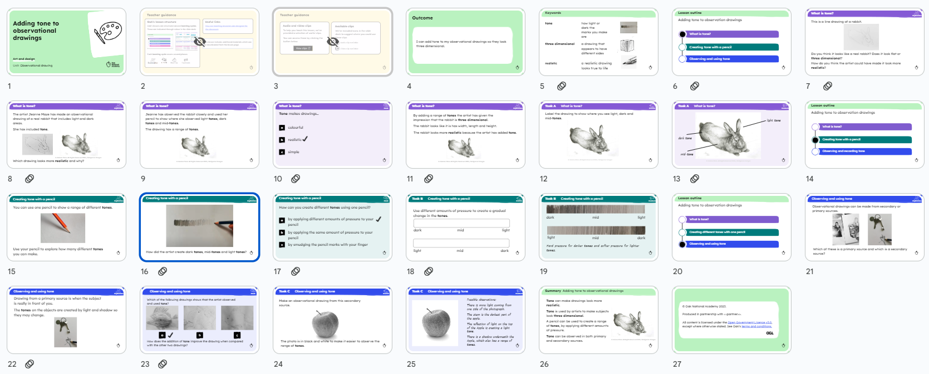
KS2 Art and design Oak slide deck

Lesson vocabulary

It is important to understand the language we use to identify aspects of lessons:
Lesson vocabulary |  |  |  |  |  |  |  |  |  |  |  |  |  |  |  |  |  |  |  | Definition |  |  |  |  |  |  |  |  |  |  |  |  |  |  |  |  |  |  |  | ✔ Examples
Lesson outcome |  |  |  |  |  |  |  |  |  |  |  |  |  |  |  |  |  |  |  | The aim of the lesson which will guide all planning. |  |  |  |  |  |  |  |  |  |  |  |  |  |  |  |  |  |  |  | 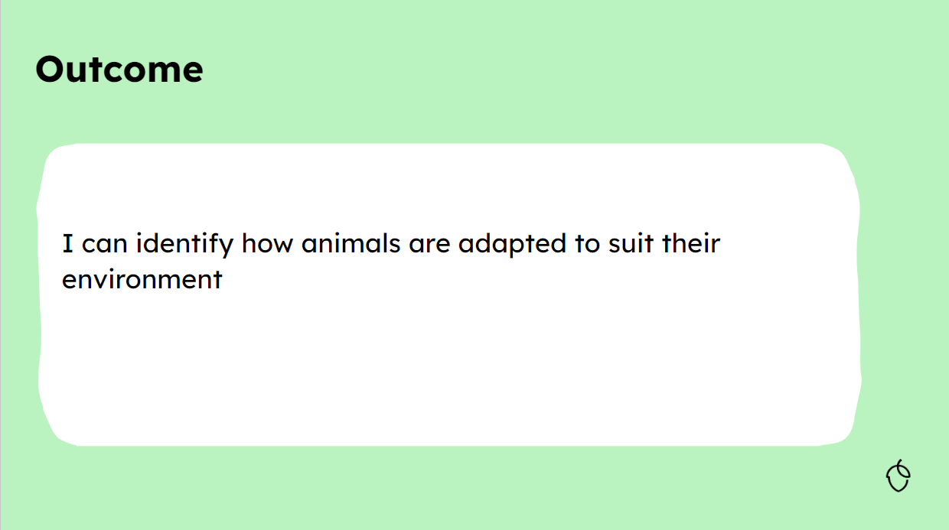
Lesson outline |  |  |  |  |  |  |  |  |  |  |  |  |  |  |  |  |  |  |  | This is the overview of the learning to be covered in the whole lesson and is broken down into learning cycles. Lesson outline items are chunks of learning, not necessarily objectives - sections of learning focused on a theme, idea or concept. |  |  |  |  |  |  |  |  |  |  |  |  |  |  |  |  |  |  |  | 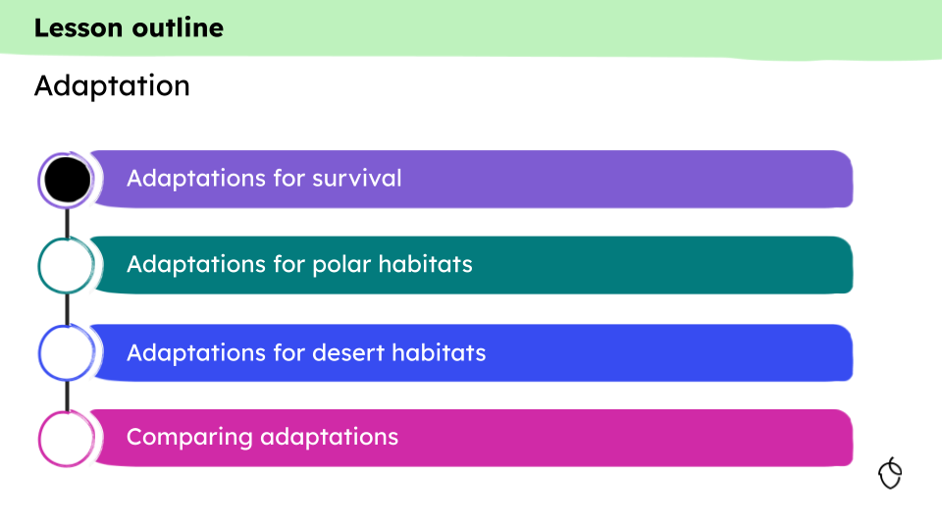
Learning cycle |  |  |  |  |  |  |  |  |  |  |  |  |  |  |  |  |  |  |  | Oak lessons are structured around learning cycles and they are indicated through colour in the slide deck. Each cycle represents a section of learning focused on a theme, idea or content.  Each learning cycle will consist of an explanation, check for understanding (CfU), practice and feedback. There are likely to be between two and four learning cycles in a lesson.  A learning cycle will always start with explanations which will be assessed through checks for understanding peppered throughout. Practice will follow and finally feedback.  Slide titles in the banner of learning cycle slides will match the corresponding outline bullet. |  |  |  |  |  |  |  |  |  |  |  |  |  |  |  |  |  |  |  |   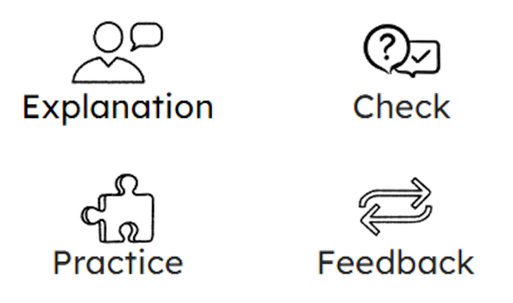
Key learning points |  |  |  |  |  |  |  |  |  |  |  |  |  |  |  |  |  |  |  | These are up to five (but minimal) important pieces of learning i.e. the main knowledge which needs to be covered within a lesson. They form part of curriculum information. They do not necessarily sit neatly within a single learning cycle. They will be published on the website for teacher users and will guide the creation of the lesson. |  |  |  |  |  |  |  |  |  |  |  |  |  |  |  |  |  |  |  | 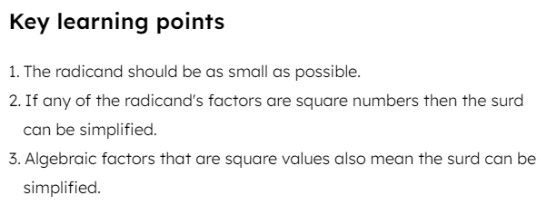
Click here to navigate to the website page which helps teachers users understand how to use Oak lessons.

It is important to look at examples of lessons so you can see how the components work together. Please note the following:

- Curriculum information is found in the Curriculum Authoring Tool.

- Quizzes may be viewed via Quiz builder which is part of the Curriculum Authoring Tool or as a PDF if you click the preview quiz button


Example lessons are available below:

Primary
 |  |  |  |  |  |  |  |  |  |  |  |  |  |  |  |  |  |  |  |  |  |  |  |  |  |  |  |  |  |  |  |  |  |  |  |  |  |  |  |  |  |  |  |  | 
Art and design  - Curriculum information  - Slide deck  - Prior knowledge starter quiz  - Exit assessment quiz  - Worksheet  - Worksheet answers |  |  |  |  |  |  |  |  |  |  |  |  |  |  | Computing  - Curriculum information  - Slide deck  - Prior knowledge starter quiz  - Exit assessment quiz  - Worksheet  - Worksheet answers |  |  |  |  |  |  |  |  |  |  |  |  |  |  | Cooking and nutrition  - Curriculum information  - Slide deck  - Prior knowledge starter quiz  - Additional materials  - Exit assessment quiz  - Worksheet  - Worksheet answers |  |  |  |  |  |  |  |  |  |  |  |  |  |  | Music  - Curriculum information  - Slide deck  - Prior knowledge starter quiz  - Exit assessment quiz  - Worksheet  - Worksheet answers
 |  |  |  |  |  |  |  |  |  |  |  |  |  |  |  |  |  |  |  |  |  |  |  |  |  |  |  |  |  | 
Religious education  - Curriculum information  - Slide deck  - Prior knowledge starter quiz  - Additional materials  - Exit assessment quiz  - Worksheet  - Worksheet answers |  |  |  |  |  |  |  |  |  |  |  |  |  |  | RHE  - Curriculum information  - Slide deck  - Prior knowledge starter quiz  - Exit assessment quiz  - Worksheet  - Worksheet answers |  |  |  |  |  |  |  |  |  |  |  |  |  |  | Spanish  - Curriculum information  - Slide deck  - Prior knowledge starter quiz  - Additional materials  - Exit assessment quiz  - Worksheet  - Worksheet answers
Secondary
 |  |  |  |  |  |  |  |  |  |  |  |  |  |  |  |  |  |  |  |  |  |  |  |  |  |  |  |  |  |  |  |  |  |  |  |  |  |  |  |  |  |  |  |  | 
Art and design  - Curriculum information  - Slide deck  - Prior knowledge starter quiz  - Exit assessment quiz  - Worksheet  - Worksheet answers |  |  |  |  |  |  |  |  |  |  |  |  |  |  | Citizenship  - Curriculum information  - Slide deck  - Prior knowledge starter quiz  - Exit assessment quiz  - Worksheet  - Worksheet answers |  |  |  |  |  |  |  |  |  |  |  |  |  |  | Computing  - Curriculum information  - Slide deck  - Prior knowledge starter quiz  - Exit assessment quiz  - Worksheet  - Worksheet answers |  |  |  |  |  |  |  |  |  |  |  |  |  |  | Design and technology  - Curriculum information  - Slide deck  - Prior knowledge starter quiz  - Exit assessment quiz  - Worksheet  - Worksheet answers
 |  |  |  |  |  |  |  |  |  |  |  |  |  |  |  |  |  |  |  |  |  |  |  |  |  |  |  |  |  |  |  |  |  |  |  |  |  |  |  |  |  |  |  |  | 
French  - Curriculum information  - Slide deck  - Prior knowledge starter quiz  - Additional materials  - Exit assessment quiz  - Worksheet  - Worksheet answers |  |  |  |  |  |  |  |  |  |  |  |  |  |  | KS3 geography  - Curriculum information  - Slide deck  - Prior knowledge starter quiz  - Exit assessment quiz  - Worksheet  - Worksheet answers |  |  |  |  |  |  |  |  |  |  |  |  |  |  | KS4 geography  - Curriculum information  - Slide deck  - Prior knowledge starter quiz  - Exit assessment quiz  - Worksheet  - Worksheet answers |  |  |  |  |  |  |  |  |  |  |  |  |  |  | Physical education (theory)  - Curriculum information  - Slide deck  - Prior knowledge starter quiz  - Exit assessment quiz  - Worksheet  - Worksheet answers
 |  |  |  |  |  |  |  |  |  |  |  |  |  |  | 
Religious education  - Curriculum information  - Slide deck  - Prior knowledge starter quiz  - Exit assessment quiz  - Worksheet  - Worksheet answers |  |  |  |  |  |  |  |  |  |  |  |  |  |  | RSHE  - Curriculum information  - Slide deck  - Prior knowledge starter quiz  - Exit assessment quiz  - Worksheet  - Worksheet answers

Oak National Academy analytics data (1st September 2022 and 16th July 2023)
Oak National Academy analytics data (1st September 2022 and 16th July 2023)
Skiba, R., Ormiston, H., Martinez, S. and Cummings, J., 2016. Teaching the social curriculum: Classroom management as behavioural instruction. Theory into practice, 55(2), pp.120-128.
Martin, A.J., 2016. Using Load Reduction Instruction (LRI) to boost motivation and engagement. Leicester: British Psychological Society.
Eysink, T.H., Gersen, L. and Gijlers, H., 2015. Inquiry learning for gifted children. High ability studies, 26(1), pp.63-74.
Clark, R.E., Kirschner, P.A. and Sweller, J., 2012. Putting Students on the Path to Learning: The Case for Fully Guided Instruction. American Educator, 36(1), pp.6-11.
Mansworth, Megan. 2021, Teach to the Top: Aiming high for every learner
Images from the nounproject

